User Manual

**for**

**CBT Real Time 1.0**

[akapetanovic@gmail.com](mailto:akapetanovic@gmail.com)

March 6, 2013

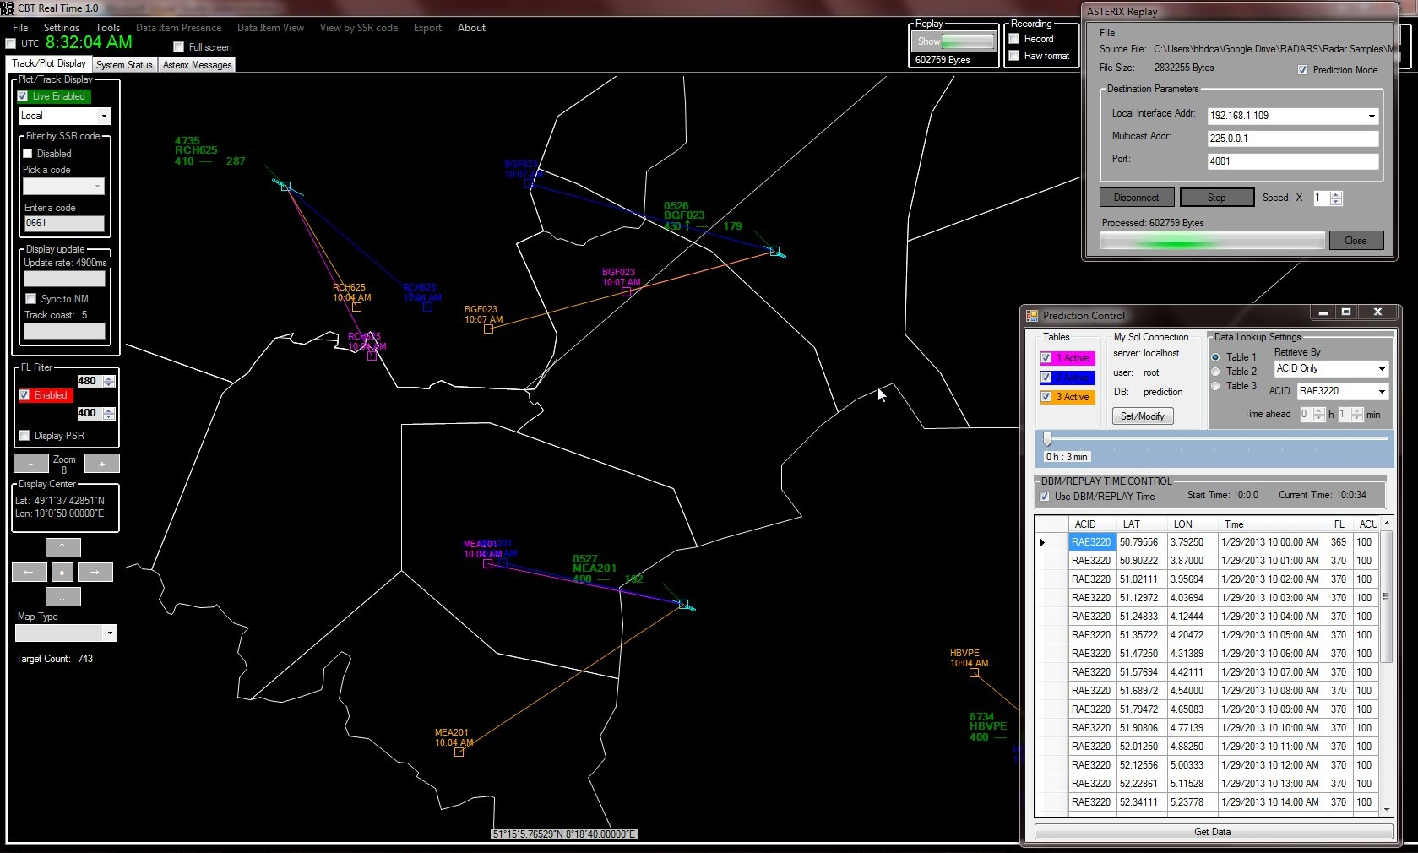

Table of Contents

[Foreword 4](#_Toc350323726)

[Related Documents 4](#_Toc350323727)

[Initial Setup 5](#_Toc350323728)

[Figure 1: CBT Real Time Block Diagram 5](#_Toc350323729)

[Prediction Control 6](#_Toc350323730)

[Figure 2: Prediction Control 6](#_Toc350323732)

[Figure 3: Three predictions enabled 7](#_Toc350323733)

[Figure 4: DBM/REPLAY Time Control enabled 8](#_Toc350323734)

[CBT Real Time Replay Mode 8](#_Toc350323735)

[Figure 5: CBT Real Time Replay Mode 9](#_Toc350323736)

[Figure 6: RAE3220 with three predictions shown 10](#_Toc350323737)

# Foreword

The baseline software for CBT Real Time was ASTERIX DARR 2.8[[1]](#footnote-1). It was created under the umbrella of the CHMI Backup System (further referenced as CBS) project led by The Maastricht Upper Area Control center. The original functionality of the ASTERIX DARR 2.8 was preserved and CBS specific requirements were implemented as an addition. The rationale for such a design decision was opportunity to reuse existing ASTERIX decoding and data display functionality, thus reducing the risk and cost of the overall project. In addition, the dependency on Visual Basic Pack was removed so that application is purely .NET 4.0 (*can be compiled for .NET 3.5 as well*), which simplifies the installation procedure.

This User Manual covers CBS specific functionality and its specific requirements. For the baseline functionality please refer to the *ASTERIX DARR UM 2.8 (February 27 2013)*.

# Related Documents

* ASTERIX DARR UM 2.8 (February 27 2013)
* CHMI Backup System – High Level Requirements (February 05 2013)

# Initial Setup

CBT Real Time application is a .NET 4.0 desktop application intended to run on a Windows (XP, Vista or WIN7) machine. Ideally, it should be hosted in the same machine that hosts My SQL (Prediction Tables) DBM and WEB server that hosts the CBT Real Time application. In addition to this it also needs to have LAN access to the ASTERIX CAT62 data. However, this is not a mandatory requirement as application can be configured to access the following necessary resources from a different physical machine:

1. Access to My SQL (Prediction Tables) server (*via connection string*)
2. Access to CAT62 data stream via LAN (*multicast address and IP port number*)
3. Access to a shared network drive/folder (***Required only for the WEB based CBT support***)

*(A place where xx.xml or xx.txt file is placed and used by the CBT Real Time WEB application. This file contains the latest real time track information extracted from CAT62 since the last update cycle)*

If desired more than one stand alone application instance can be hosted on any desktop machine as long as the first two listed requirements are satisfied.

### C:\Users\bhdca\Google Drive\Projects\WBTD\User Manaual\Block Diagram 1.jpg

### Figure 1: CBT Real Time Block Diagram

Once successfully installed it is recommended to check that access to My SQL server and CAT62 data streams are available. To check the access to My SQL server please refer to the “*Prediction Control*” section of this UM. To check access and proper processing of CAT62 data streams please refer to the ASTERIX DARR UM 2.8 (February 27 2013), page 8 and 9.

In the case the application does not have access to the live data and it is to be used with a pre-recorded data using the built in ***Replay – Prediction Mode***, please refer to the “CBT Real Time Replay Mode” section of this UM.

# Prediction Control

The main GUI for the CBT functionality is called Prediction Control. It is accessed from the Main application window via ***Tools -> Prediction Control*** menu. This window is a top most window, meaning that it will always be displayed on the top of other opened windows. It contains all the tools to manage CBT Real Time functionality and interface with the My SQL database.

### *C:\Users\bhdca\Google Drive\Projects\WBTD\User Manaual\Prediction Control.jpg*

### Figure 2: Prediction Control

***Checking/Modifying My SQL connection***

Before doing anything else it is recommended to first check the connection to the My SQL database. By default the following parameters are set for the connection string, but it is possible to change them via Set/Modify button.

Server: *localhost*

User: *root*

DB name: *prediction*

To check the status of the connection click on the Set/Modify button and a new window will pop up. Now click on the “Test Connection” button and a message indicating connection status will pop up. In the case it is failed please check that My SQL instance specified by the connection parameters is running. If necessary modify the connection parameters and try again until successful connection is established. Save the new connection setting by clicking on Save and Close button.

***Checking DB content***

To check the content of the Data Base (One of the three prediction tables) “Data Lookup Settings” are provided. It is possible to use one of the provided filters. Once desired table is selected and filters set clink on “Get Data” button to retrieve the data.

***Enabling CBT Real Time Prediction Display***

Check the desired check box under the “Tables” group box. It is possible to check more than one check box. The predicted position will be shown on the main data display in the same color as enabled prediction table.

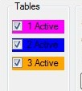

### Figure 3: Three predictions enabled

To control the predicted “time ahead” use the time slider. Once time slider is selected by the mouse it is possible to use left and right keyboard keys to precisely set the time ahead, down to a minute.

***DBM/REPLAY TIME CONTROL***

DBM/REPLAY TIME CONTROL is to be checked when application is used in the offline mode, so called CBT Real Time Replay Mode. Using this option is it possible to use application with a pre-recorded data (CAT62 and corresponding My SQL Data base) in order to evaluate DBM prediction performance or for demonstration purposes.

In this mode the application automatically selects the start time of the DBM as the application referent time so it is possible to use the time slider like the application is running in the live mode. Once Replay is started (see CBT Real Time Replay Mode) the application aligns its system time and will select appropriate DBM rows depending on the time passed.

C:\Users\bhdca\Desktop\ScreenHunter_02 Mar. 06 08.32.jpg.

### Figure 4: DBM/REPLAY Time Control enabled

# CBT Real Time Replay Mode

It is possible to use this option to use application in the offline mode in order to evaluate DBM prediction tables and its performance, or for the application demonstration purposes. To use app in this mode it is necessary to have:

* Recorded CAT62 data using the built in recorder. Refer to ASTERIX DARR User Manual 2.8 (February 27 2013), page 28 for details.
* Corresponding My SQL DBM, generated for the same ASTERIX recording.
* Prediction Mode checked on ASTERIX Replay GUI checked.

NOTE: It is important that starting time of the recording (UTC) matches the starting time of the DBM generated prediction data (UTC). The ASTERIX recording can be in gengate (final format) as it later can be replayed and modified for use with CBT Real Time. For detail procedure please contact me at [akapetanovic@gmail.com](mailto:akapetanovic@gmail.com).

### C:\Users\bhdca\Google Drive\Projects\WBTD\User Manaual\Replay Mode - Prediction.jpg

### Figure 5: CBT Real Time Replay Mode

***To start replay***

1. Select appropriate recording: ***File -> file\_name.rply***
2. Click on Connect button.

*Application will by default select available LAN interface, and pre-fill multicast/IP to 225.0.0.1/4001. Should this address already be used on the given LAN, please select a different one. In the case that provided parameters are not correct an appropriate message will be displayed upon clicking on Connect button, as it actually tries to open up a socket.*

1. Click on Start button.

Start will be active upon successfully opened socket under step 2. Clicking on Start will automatically set the input parameters and start processing the data.

1. Check that display filters are appropriately set and that plot/track display is enabled.

### C:\Users\bhdca\Desktop\ScreenHunter_01 Mar. 06 08.30.jpgFigure 6: RAE3220 with three predictions shown

***Amer Kapetanovic***

***(akapetanovic@gmail.com)***

1. http://sourceforge.net/projects/asterixanalyser/?source=directory [↑](#footnote-ref-1)